In 2011, an estimated 22 million people lived fairly peacefully in Syria. Since then, more than half of those people have been displaced. Where have the gone? Each symbol below represents 250,000 people. Journey slowly along the path to learn where Syrians are living now. Take your time. Pray and reflect as you go. Pay attention to the feelings that come up as you look at the pictures


In 2011, an estimated 22 million people lived in Syria. Since then, more than half of those people have been displaced during the conflict.
Where have they gone?

Journey slowly along the path to learn where Syrians are living now. Take your time. Pray and reflect as you go. Pay attention to the feelings that come up as you look at the pictures

Syrian Map

Less than 10 million of the population of 22 million Syrian people have been able to remain in their homes.

Using the scissors, separate a group of 39 symbols, representing 9,750,000 people from the sheet. Place this group on the large map of Syria, to represent those who have been able to remain in place. Keep the remaining 49 symbols for later.

Pictures of protest, Syrian live and conflict

An estimated 330,000 Syrians
have died since the conflict began.
To put this in perspective, in all US Wars combined there have
been 660,000 deaths in battle.
Remove 2 symbols, representing those who have died, from your sheet. Place them….

Have an appropriate location to represent those who have died. We used a small, decorative box with candles near.

The 47 symbols that remain in your hand represent
over 12 million people who have been displaced since the conflict began.

Where have they gone?

Pictires of Syrian people on the move, conflict, Syrian neighborhoods.

7 million
Syrians have had to move, but have stayed within Syria.
Cut 28 individual symbols from your sheet.
Scatter them around the map of Syria.

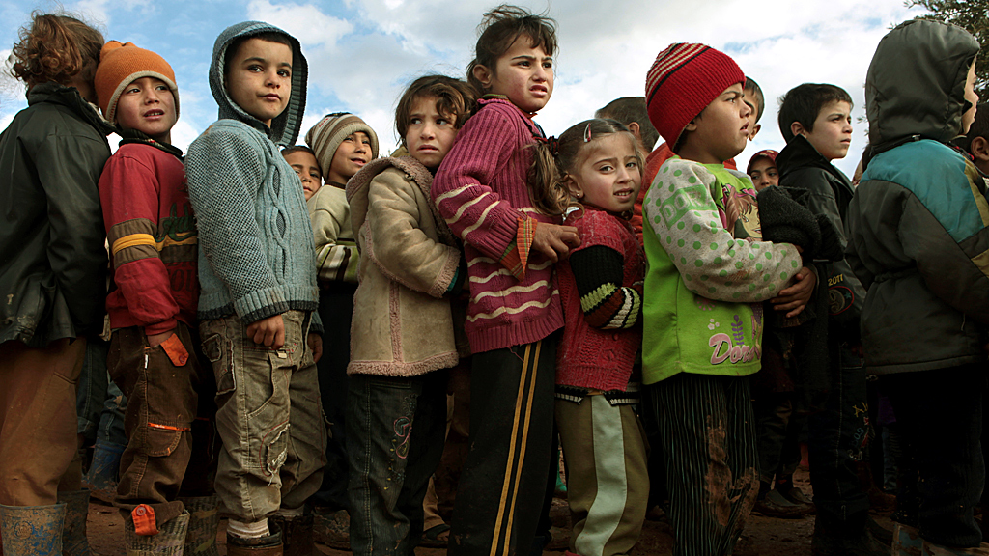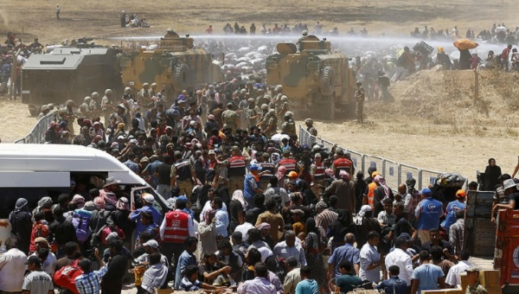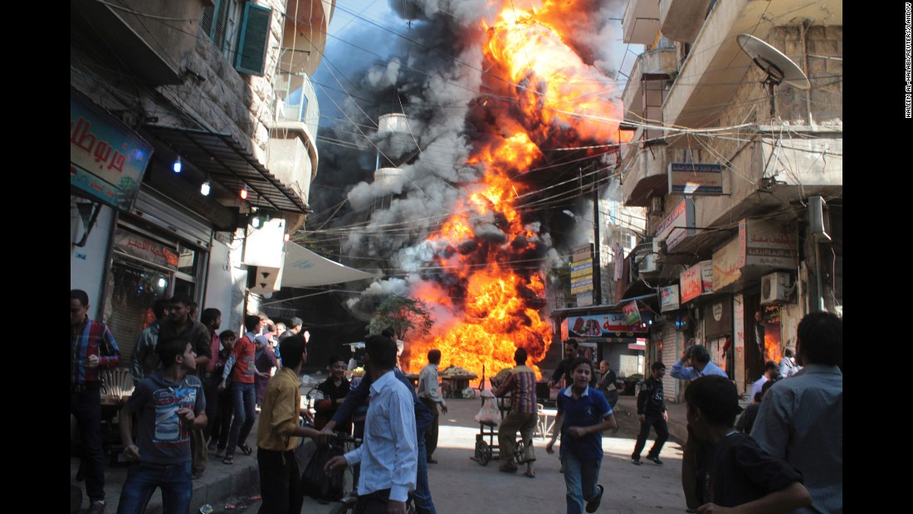
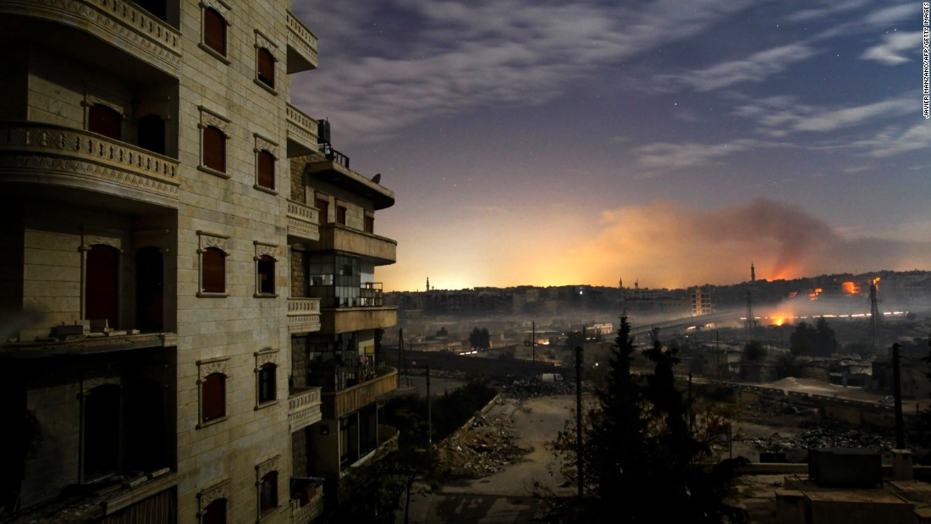
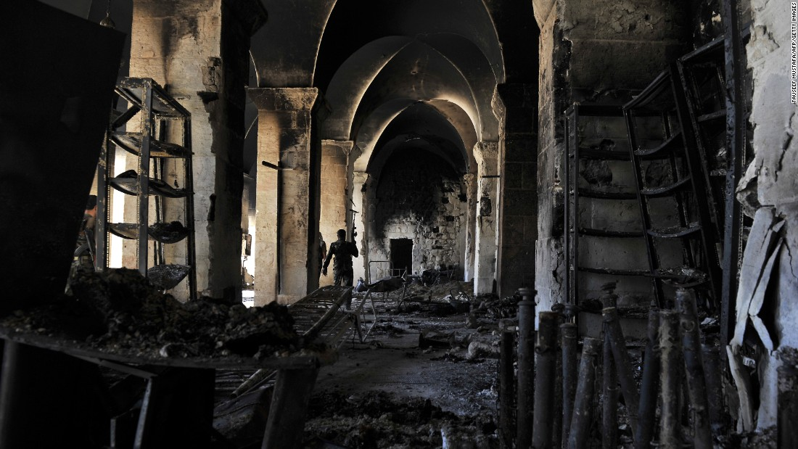

5 million Syrians have had to leave their country.
2.5 million of those people are children.

Pause here, and write a prayer for the children.
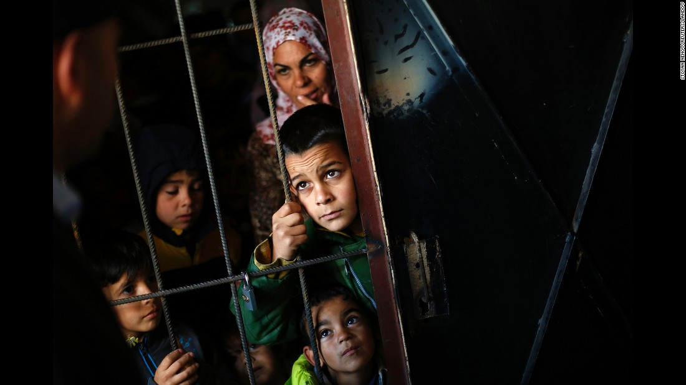
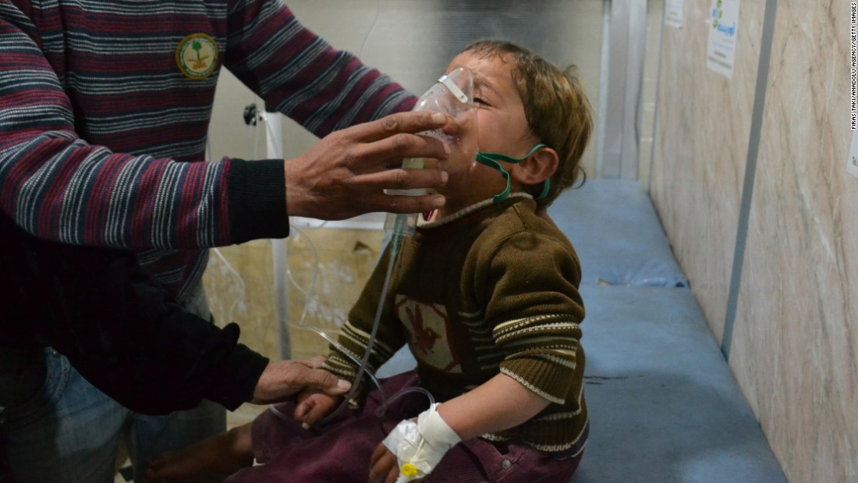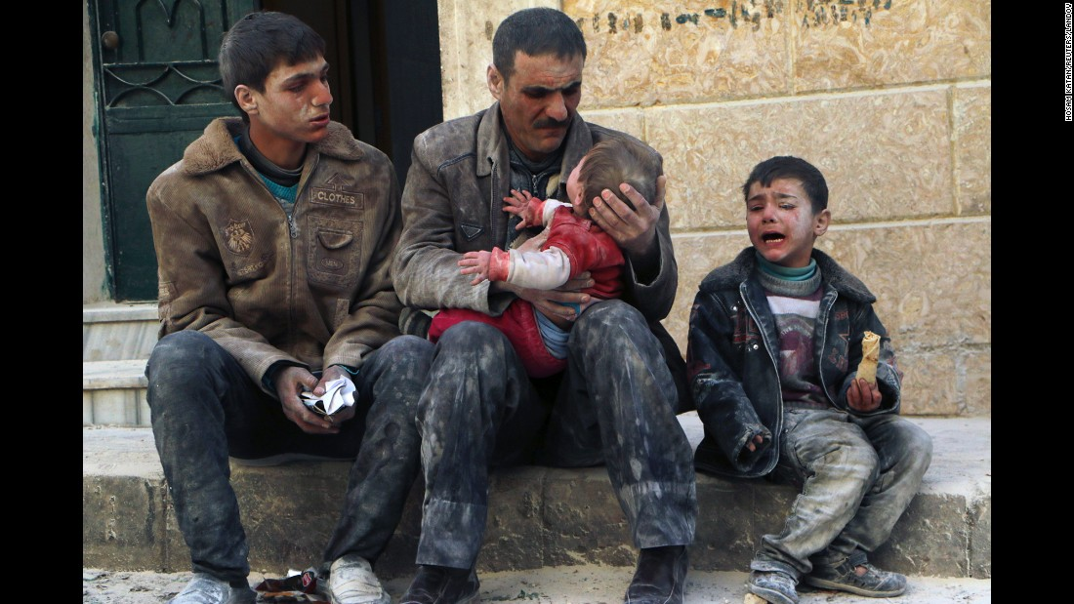
The largest number of Syrian refugees are in Turkey:
1.9 million
Many live in refugee camps.

Cut 8 symbols from your sheet, representing nearly 2 million people. Place 7 of near the map of Turkey.
Keep one symbol with you for the next step.
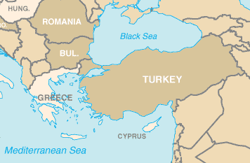 Syria
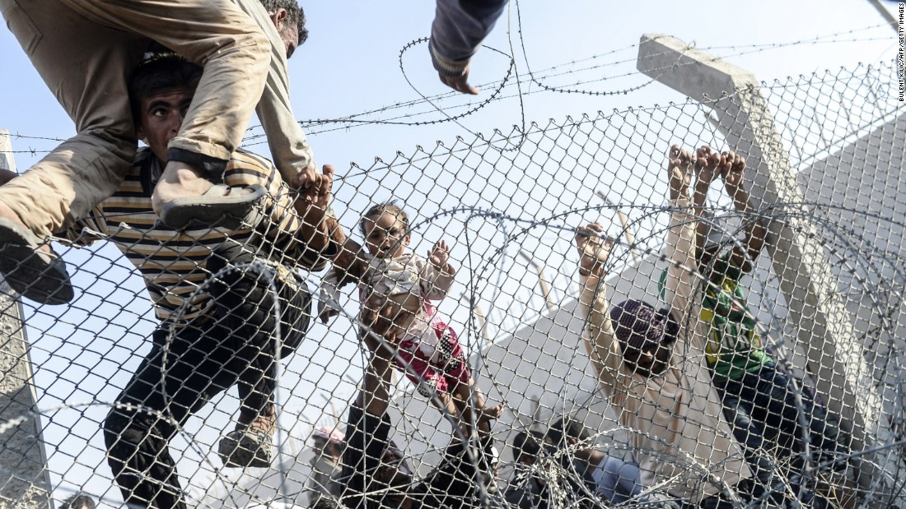
Crossing the Turkish border.
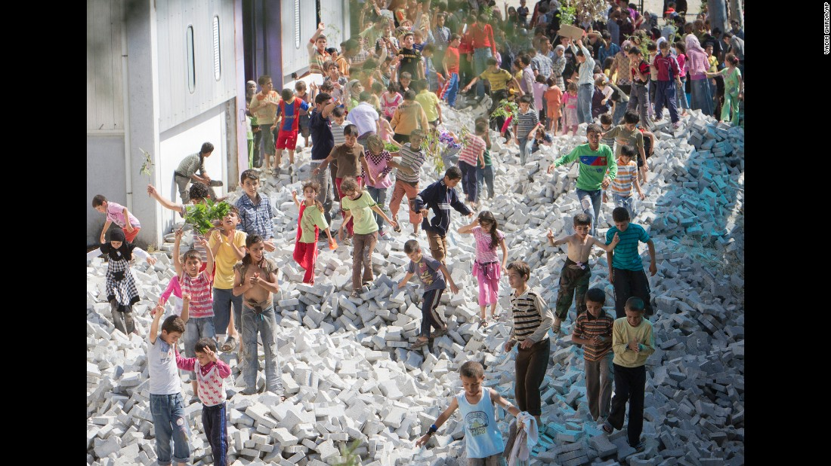
Syrian children in Turkey protest.
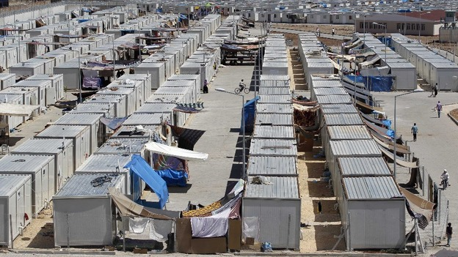
A Turkish Refugee Camp
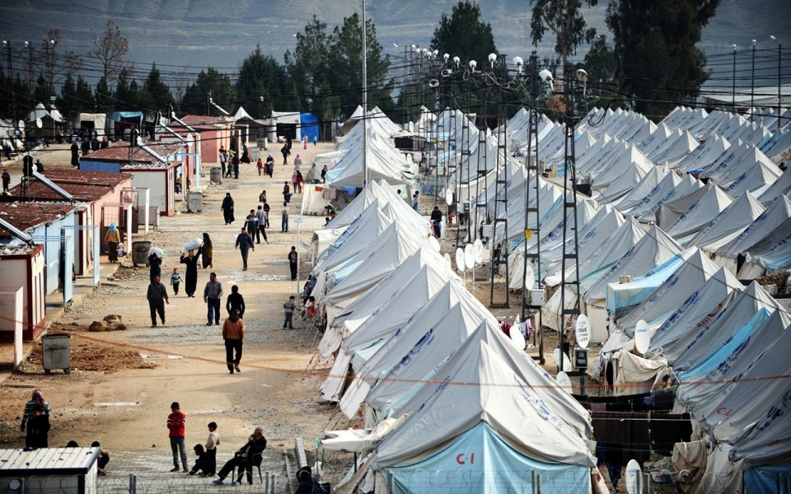
A Turkish Refugee Camp
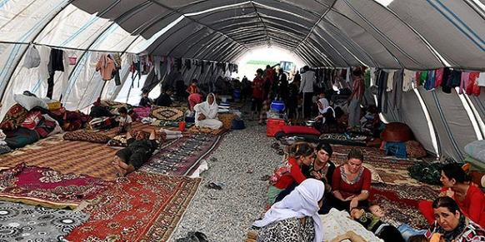
A Turkish Refugee Camp

Approximately 278,000 Syrians who have made it to Turkey move on to Europe over land or on small boats.

Reflect on the infographic which shows where Syrians in Europe have traveled. Leave the one symbol you reserved from Turkey here.
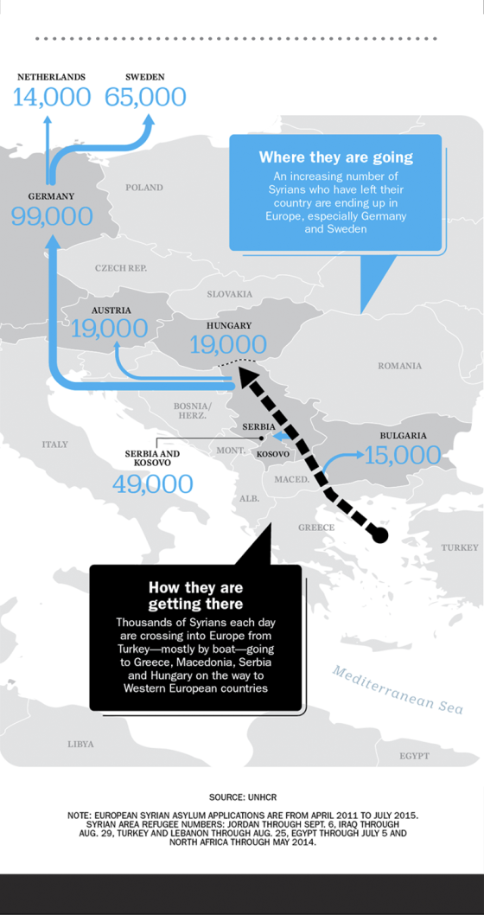

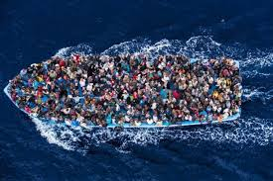
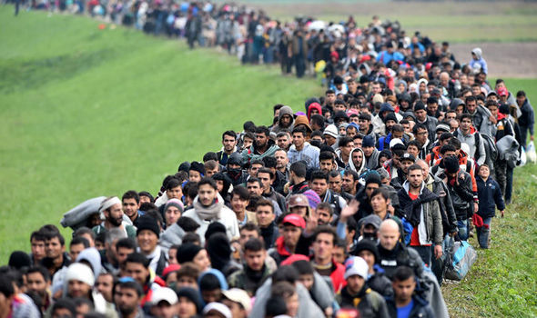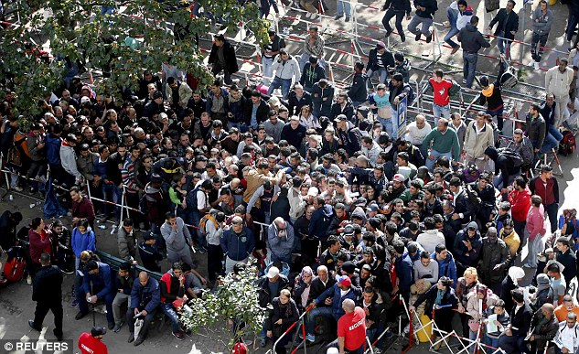
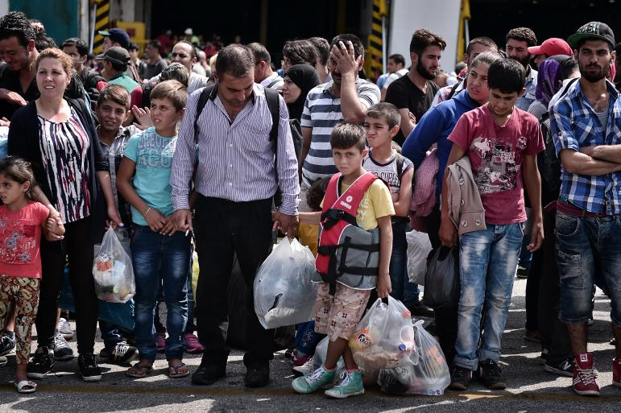
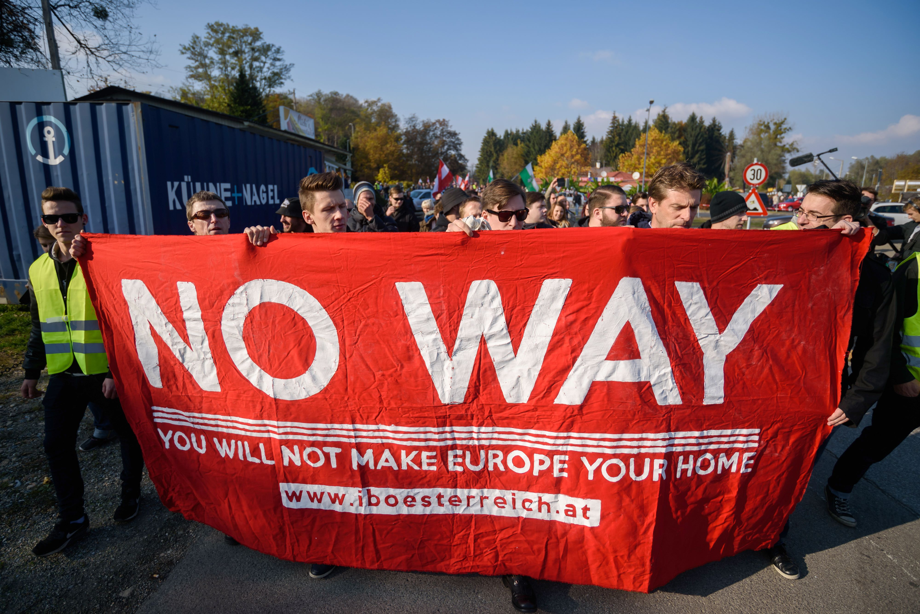
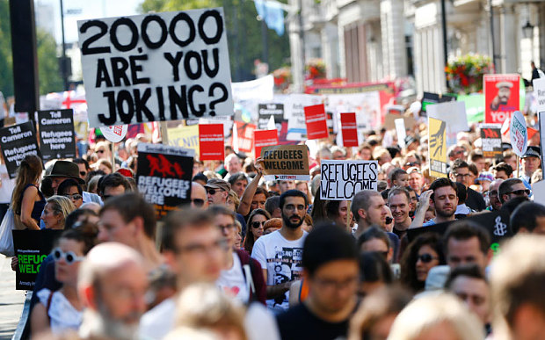
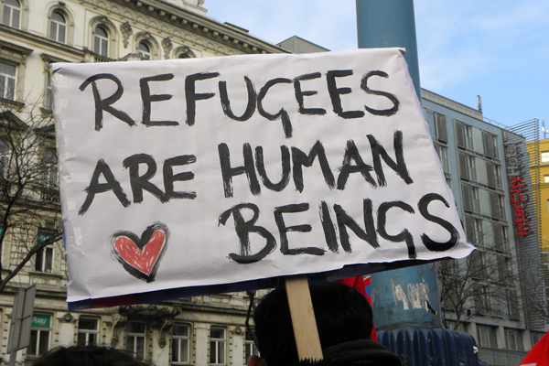
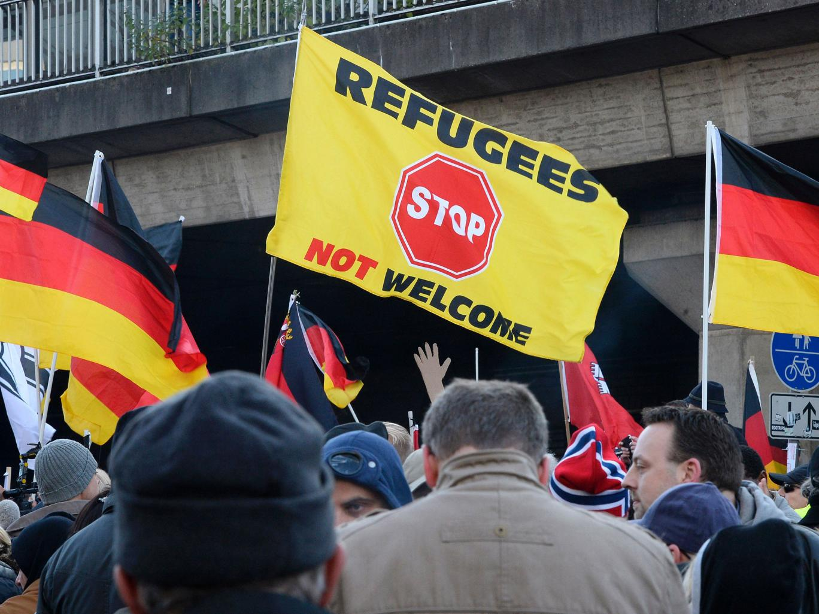
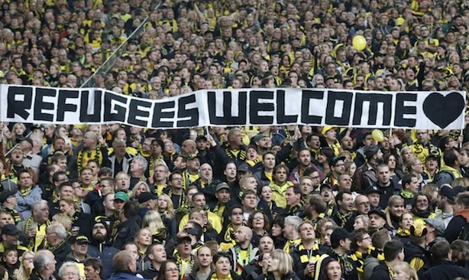
The second largest population of Syrian refugees is in Lebanon.
Over 1.25 million
The Lebanese government refuses to set up camps. The camps that exist are run by communities or non-profits. Others to find places to stay in cities
Place 6 symbols , representing 1 million people, near the map of Lebanon.
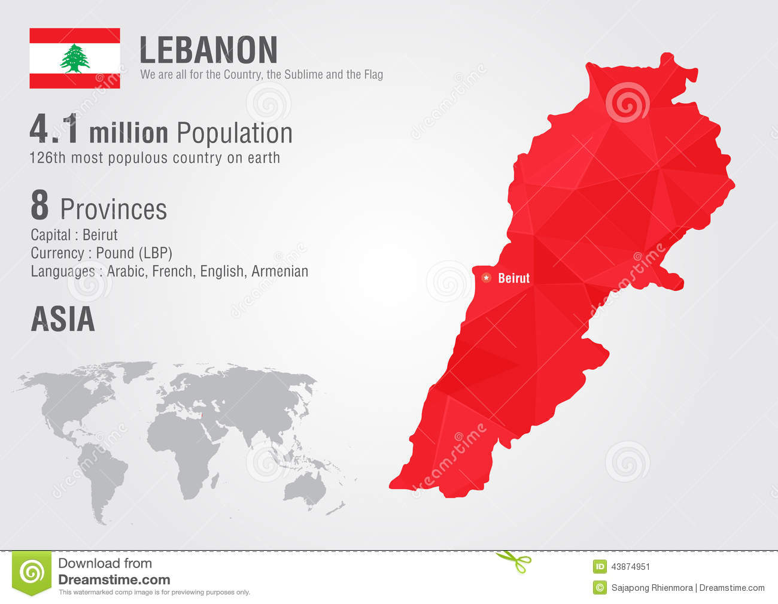
Lebanon is a small country, about the size of Connecticut, just west of Syria. Note that Lebanon only has population of 4 million to begin with.
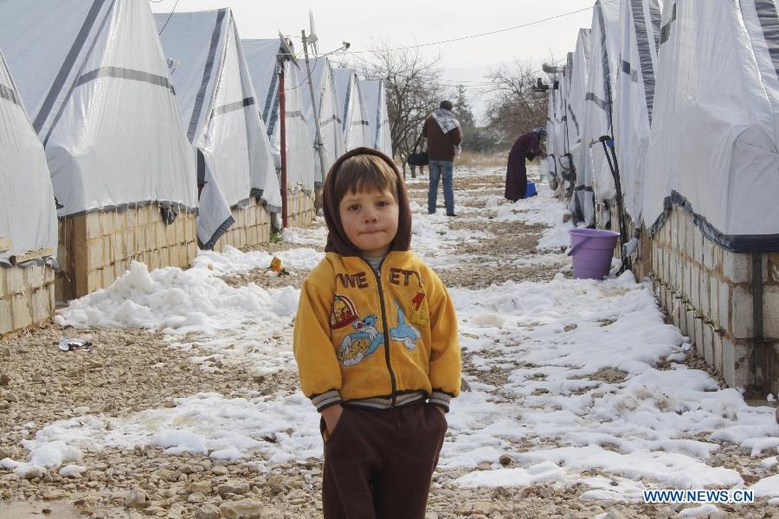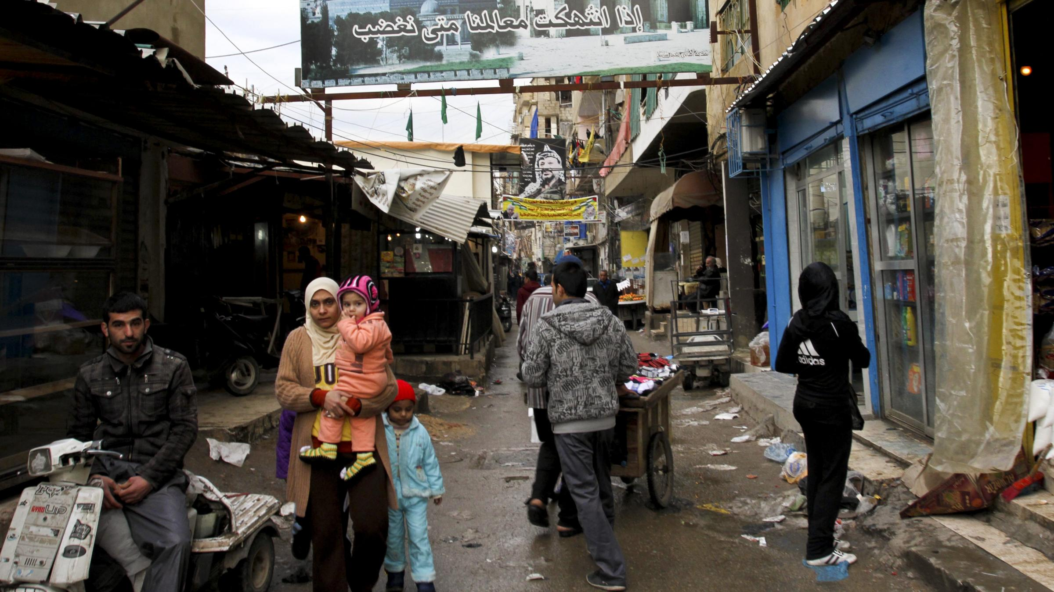
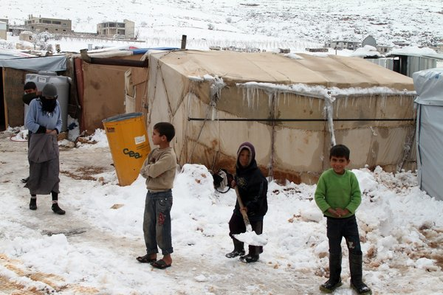
629,000 refugees are in the country of Jordan.
The largest refugee camp of all, Zaatari, is home to
80,000 people.
This is equivalent to the entire population of Buffalo Grove and Park Ridge combined.
Or, Lake Bluff, Northbrook and Glenview combined.
Place 3 symbols near the map of Jordan.

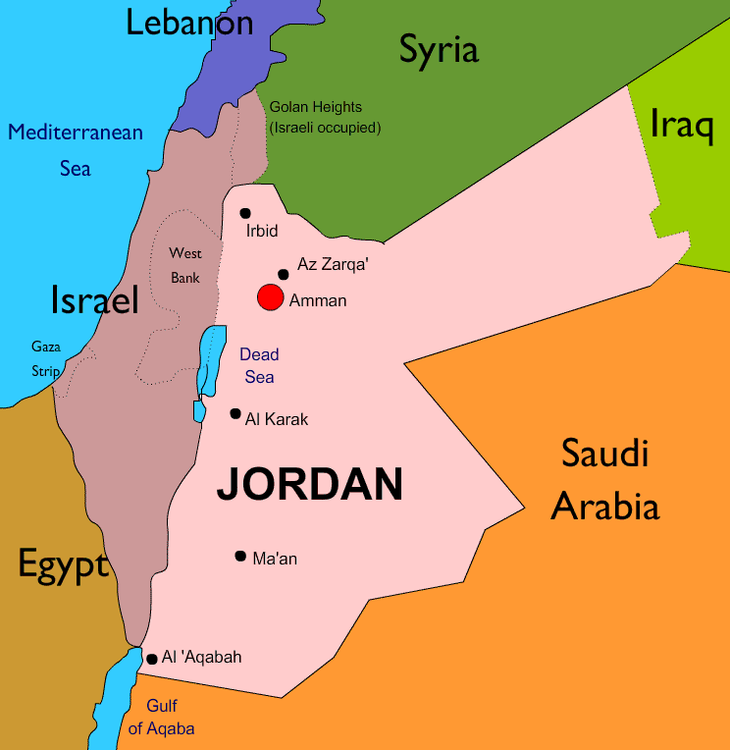
Jordan is roughly the size of the state of Indiana
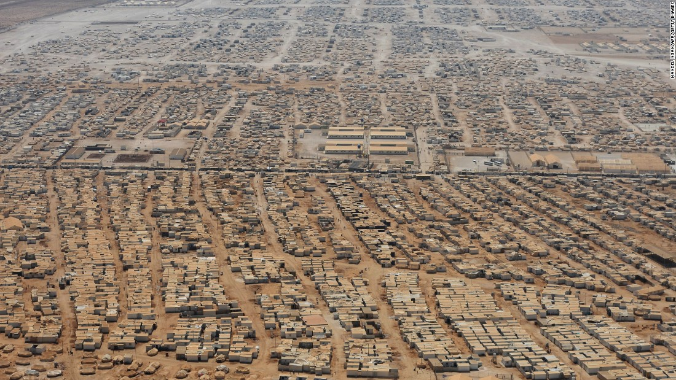
Zaatri Refugee Camp, Jordan
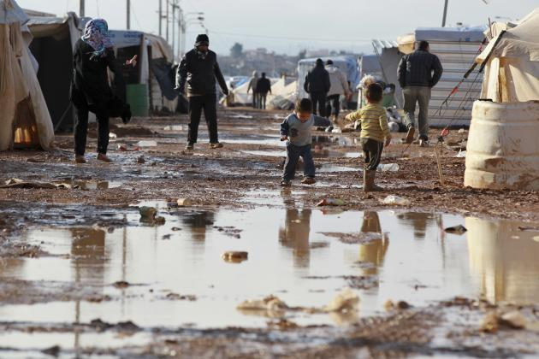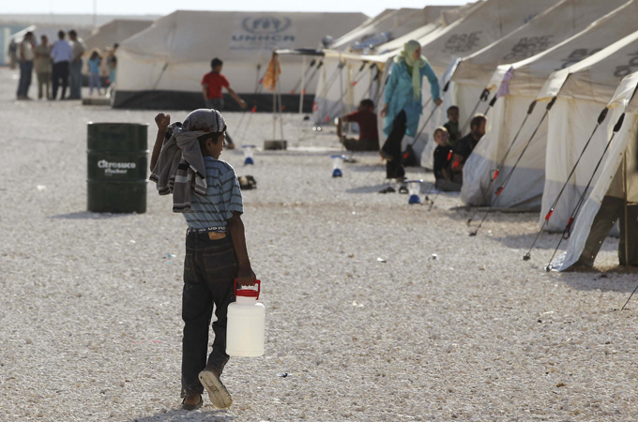

Iraq, Egypt and North Africa house most of the remaining refugees.

Place the remaining symbols here.
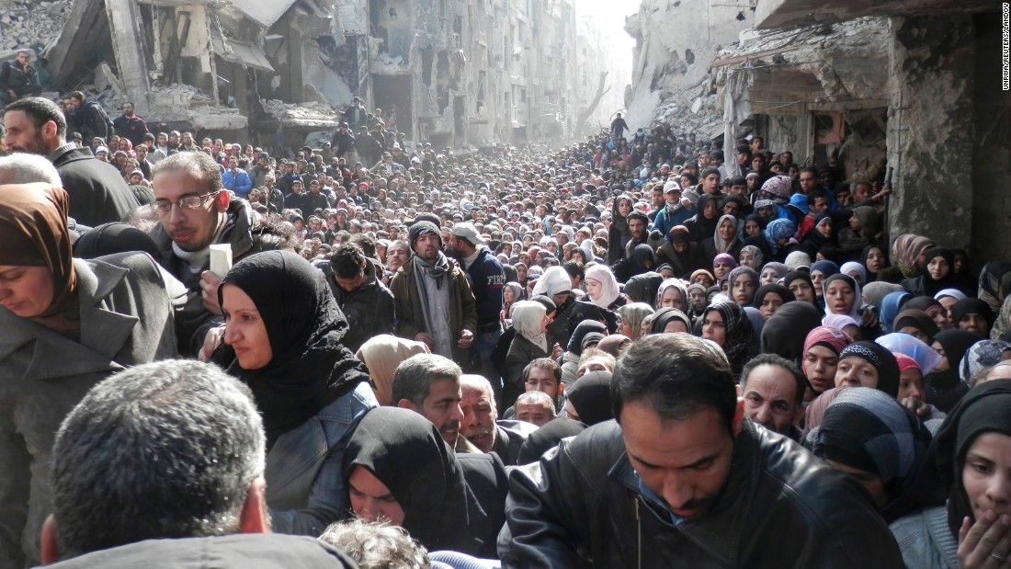

Pause to think about the large numbers of people who have been displaced from just one country.
What questions come to your mind?
Write them on the cards and leave them for the panel discussion.

