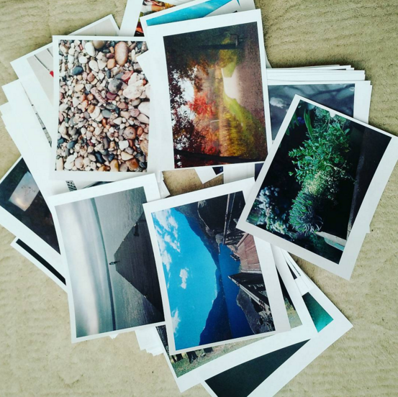
Psalm Imagery

Choose a Psalm: Read and reflect upon one of the readings for Lent. What images or feelings come to mind?

Match an Image: Look through the photographs. Choose one that reminds you of the psalm you read. How does this image relate to how you understand God?

Place: Tape the photo you chose to the psalm. Look for the pairing on social media in the coming weeks!

Instagram: @
Facebook:

