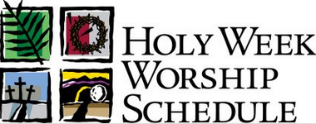

Palm Sunday, April 9
Insert service times

Holy Thursday, April 13
Insert service times

Good Friday, April 14
Insert service times

Saturday, April 15
Insert service times

Easter Sunday
Insert service times

Name of Church and Website

Palm Sunday, April 9
Insert service times

Holy Thursday, April 13
Insert service times

Good Friday, April 14
Insert service times

Saturday, April 15
Insert service times

Easter Sunday
Insert service times

Name of Church and Website

Palm Sunday, April 9
Insert service times

Holy Thursday, April 13
Insert service times

Good Friday, April 14
Insert service times

Saturday, April 15
Insert service times

Easter Sunday
Insert service times

Name of Church and Website

Palm Sunday, April 9
Insert service times

Holy Thursday, April 13
Insert service times

Good Friday, April 14
Insert service times

Saturday, April 15
Insert service times

Easter Sunday
Insert service times

Name of Church and Website

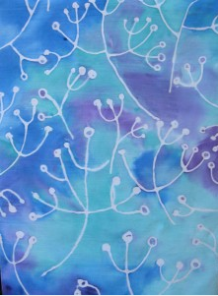
Palm Sunday
Jesus Enters Jerusalem
Like a King
Matthew 21:1-10

Monday
Jesus Goes to the Temple
Matthew 21:12-17

Tuesday
Jesus Teaches the
greatest commandment
Matthew 22: 34-39

Wednesday
A Woman Does Something Special
Matthew 26:6-12

Holy Thursday
The Lord’s Supper
Matthew 26:26-30

Good Friday
The Soldiers Make Fun of Jesus
Matthew 27:27-31
Jesus is Buried
Matthew 27:57-61

Saturday
The Guard at the Tomb
Matthew 27: 62-66

Easter Sunday
The Resurrection of Jesus
Matthew 28: 1-10, John 20:1-18

Palm Sunday
Jesus Enters Jerusalem
Like a King
Matthew 21:1-10

Monday
Jesus Goes to the Temple
Matthew 21:12-17

Tuesday
Jesus Teaches the
greatest commandment
Matthew 22: 34-39

Wednesday
A Woman Does Something Special
Matthew 26:6-12

Holy Thursday
The Lord’s Supper
Matthew 26:26-30

Good Friday
The Soldiers Make Fun of Jesus
Matthew 27:27-31
Jesus is Buried
Matthew 27:57-61

Saturday
The Guard at the Tomb
Matthew 27: 62-66

Easter Sunday
The Resurrection of Jesus
Matthew 28: 1-10, John 20:1-18

Palm Sunday
Jesus Enters Jerusalem
Like a King
Matthew 21:1-10

Monday
Jesus Goes to the Temple
Matthew 21:12-17

Tuesday
Jesus Teaches the
greatest commandment
Matthew 22: 34-39

Wednesday
A Woman Does Something Special
Matthew 26:6-12

Holy Thursday
The Lord’s Supper
Matthew 26:26-30

Good Friday
The Soldiers Make Fun of Jesus
Matthew 27:27-31
Jesus is Buried
Matthew 27:57-61

Saturday
The Guard at the Tomb
Matthew 27: 62-66

Easter Sunday
The Resurrection of Jesus
Matthew 28: 1-10, John 20:1-18

Palm Sunday
Jesus Enters Jerusalem
Like a King
Matthew 21:1-10

Monday
Jesus Goes to the Temple
Matthew 21:12-17

Tuesday
Jesus Teaches the
greatest commandment
Matthew 22: 34-39

Wednesday
A Woman Does Something Special
Matthew 26:6-12

Holy Thursday
The Lord’s Supper
Matthew 26:26-30

Good Friday
The Soldiers Make Fun of Jesus
Matthew 27:27-31
Jesus is Buried
Matthew 27:57-61

Saturday
The Guard at the Tomb
Matthew 27: 62-66

Easter Sunday
The Resurrection of Jesus
Matthew 28: 1-10, John 20:1-18

